**Processed Shrimp Electronic Logbook data for the Gulf of Mexico**

CASS Spatial Team

June 1, 2021

***NOTE: This data is confidential and requires a Non-Disclosure Agreement to work with.***

**Data in Folder**

The AOA GOM Study Areas contains four feature classes, one for each of the study areas. The SEFSC Shrimp Data Contains two feature classes and two rasters, see the data processing steps for more details on each dataset.

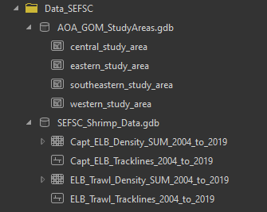

**Background:** Two data sets were received from the Southeast Fisheries Science Center (SEFSC)**.** The first was the Electronic Logbook (ELB) records for commercial shrimp trawling vessel data from 2004 to 2019 as raw text files. The ELB records, a type of Vessel Monitoring System (VMS), transmits or records a signal at 10-minute intervals that notes a vessel's location and speed over ground. An important note regarding this data is that the SEFSC categorized this data based on the speed the vessel was traveling. Importantly, when a vessel was traveling between 2.0 to 3.8 knots it was assumed the vessel was actively trawling. The second type of data received represents each tow during the time the box was installed. This is the electronic equivalent of the Captain’s manual logbook. These data included a start trawl and stop trawl locations.

**Data Processing Steps:**

***For the Electronic Logbook records***

1. A spatial point feature class was created from the raw text files (one for each year)
2. Data was cleaned and time fields formatted (Data without a VSBN was excluded
3. All points that where the recorded speed was between 2 to 3.8 knots were extracted to a new point feature class “Trawling Points”
4. The “Trawling Points” were used to create “Trawling Tracklines” with points not being connected if greater than 1 mile apart or longer than 30 min apart.
5. Lastly the Submerged Land Act shoreline file was used to remove and delete any tracks that crossed land features. *Example of Trawl lines going over land:*

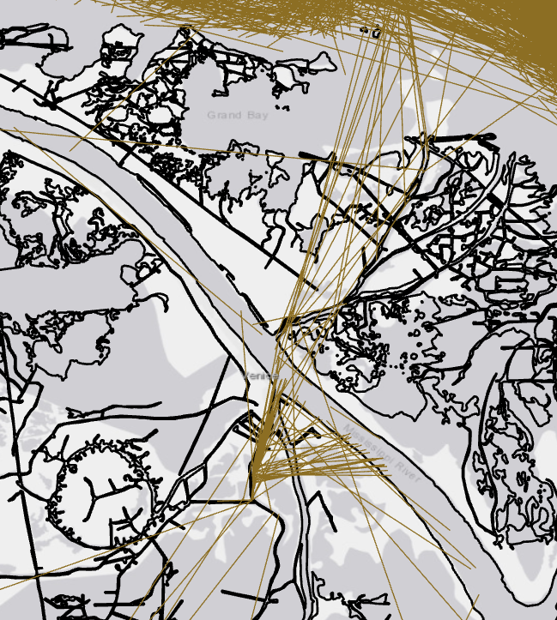

1. In addition, a density raster was created for the trawl tracklines. A raster with a 100 x 100m cell size, with each cell value = to the count of transits through that cell over 2004 to 2019. *Screenshot of raster grid:*

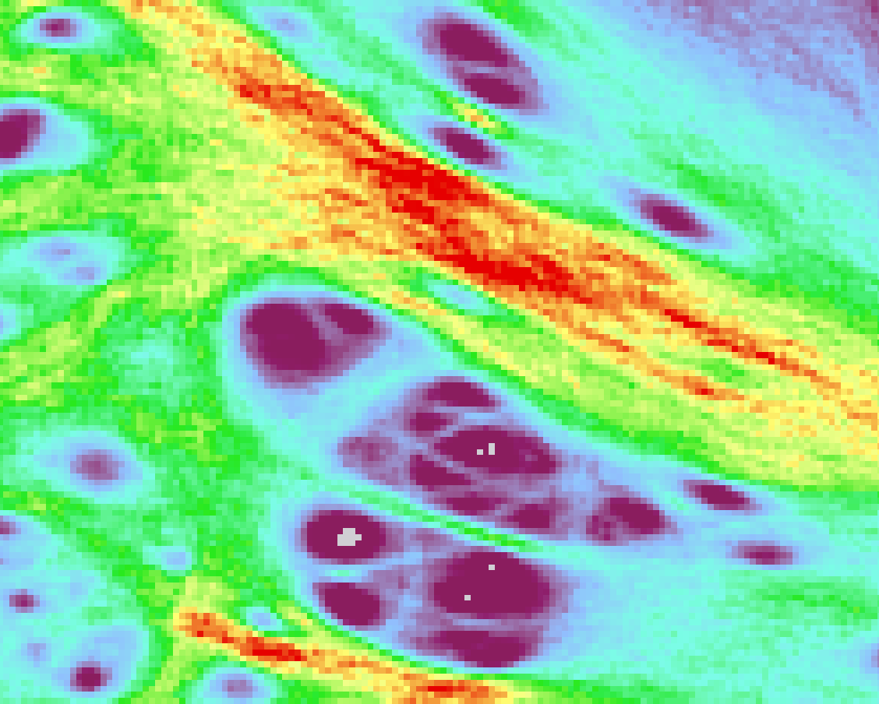

***For the second type of data (Captain’s Electronic Logbook)***

1. A spatial point feature class was created from the raw text files (one for each year)
2. If the start and end location for a trawl were the same that record was removed
3. Tracklines were created from the start and stop locations for each recorded trawl
4. Tracklines with lengths greater than 44.448 km were removed (Rationale: Assuming a vessel trawling at 4 knots for 6 hours as the absolute maximum distance a trawl would likely occur.)
5. Lastly the Submerged Land Act shoreline file was used to remove and delete any tracks that crossed land features
6. In addition, a density raster was created for the trawl tracklines. A raster with a 1000 x 1000m cell size, with each cell value = to the count of transits through that cell over 2004 to 2019. Screenshot of raster grid:

